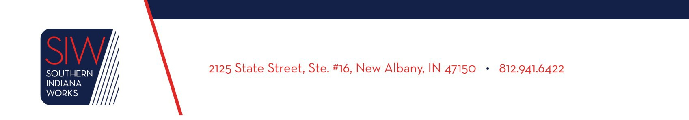

**TITLE: Southern Indiana Works Social Media Policy**

**ISSUE DATE: January 1, 2024**

**Purpose**

To establish guidelines for the use of social media within Southern Indiana Works (SIW).

**References**

* DWD Policy 2023-03 Social Media Management

**Background**

When used appropriately, social media can improve the efficiency of communication by allowing direct contact to individuals in need of information. As noted in TEGL 03-23 Allowable Uses of Funds for Outreach Activities for Federal Formula and Competitive Grant Awards, the use of funds to create social media accounts to promote the grant services offered, raise awareness of programs, and strengthen relations with the community. An online presence is the most effective way to virtually connect with customers regardless of distance. This policy has been developed to ensure the adequate representation of SIW and our brand.

**SIW Commitments**

Southern Indiana Works (SIW) Executive Management is responsible for providing guidance and periodic review of this policy. Following are the five Core Values of SIW in the Online Social Media Community:

1. **Transparency** in every social media engagement. SIW does not condone manipulating the social media flow by creating “fake” destinations and posts designed to mislead followers and control a conversation.
2. **Protection** of our customers’ privacy. This means that we should be conscientious regarding any personally identifiable information (PII) that we collect, including how we collect, store, use, or share that PII, all of which should be done pursuant to applicable privacy policies, laws and IT policies.
3. **Respect** of copyrights, trademarks, rights of publicity, and other third-party rights in the online social media space, including with regard to user generated content (UGC).
4. **Responsibility** in our use of technology. We will not use or align SIW with any organizations or websites that deploy the use of excessive tracking software, adware, malware or spyware.
5. **Utilization** of best practices, listening to the online community, and compliance with applicable regulations to ensure that this policy remains current and reflects the most up-to-date and appropriate standards of behavior.

**Content Management**

1. SIW will have one main designee that will be responsible for the content and& upkeep of social media sites. SIW website will remain the primary & predominant internet presence.
2. The best, most appropriate uses of social media tools fall generally into two categories:
   1. Channels for disseminating time-sensitive information as quickly as possible.
   2. Marketing/promotional channels to increase the workforce system’s ability to broadcast messages to the widest possible audience.
3. SIW social media sites are subject to the Indiana Access to Public Records Act. Any content maintained in a social media format that is related to SIW and /or DWD business or the implementation of any state or federally funded initiatives, including a list of subscribers and post communication, is a public record. Such content shall be maintained in an accessible format so it can be produced in response to a request.
4. All content must be pre-approved. No more than four entities will have access to SIW social media platforms.
5. All SIW social media content related to WorkOne/American Job Centers (AJCs) must abide by the provisions included in all WorkOne/AJC brand polices.

**Equal Opportunity**

The following equal opportunity language will be used on all digital marketing materials:

“*Southern Indiana Works is an equal opportunity employer/program. Auxiliary aids and services are available upon request to individuals with disabilities. TDD/TTY number for assistance is 1-800-743-3333.”*

**Required Action**

All Southern Indiana Works staff and contractors must adhere to this policy.

**Additional Information**

Questions regarding the content of this publication should be directed to the Vice President of Operations Shilese Stover at (812) 941-6422 or [Shilese@soinworks.com](mailto:Shilese@soinworks.com)